Network Packet http captured
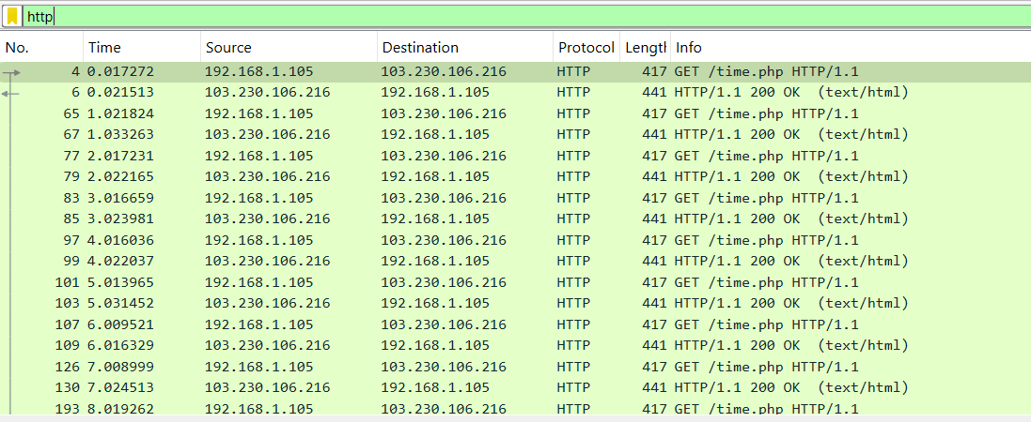

HTTP Request Packet
- Frame:
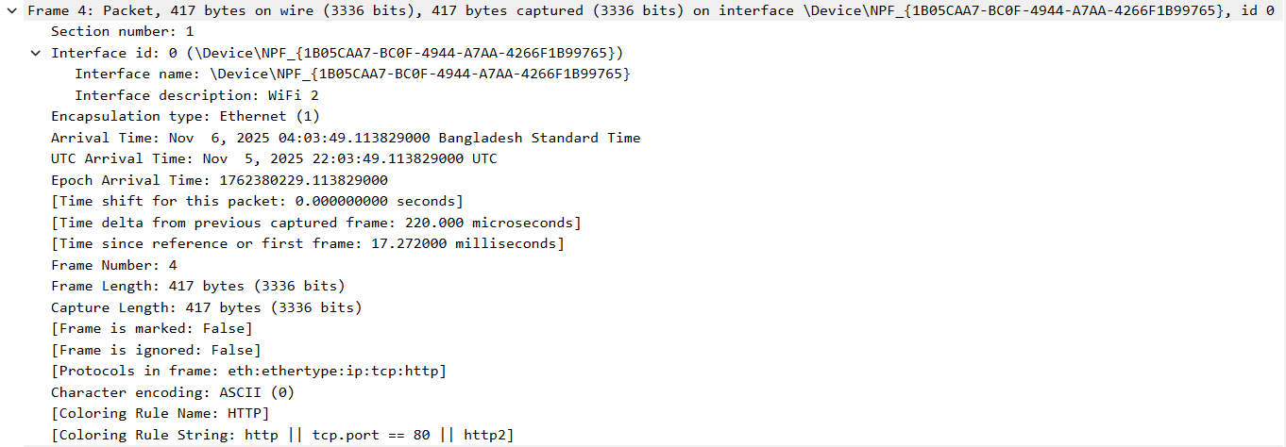
This header falls under the data link layer of the OSI model and is responsible for transferring packets between two physically connected devices in a local network.

- Ethernet:
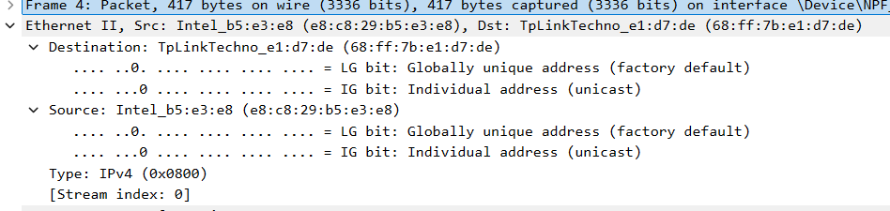
This header transfers data from the local device to the next-hop device. In this case, the sender is the laptop and the receiver is the router. Here,
The source (sender) mac address is - e8:c8:29:b5:e3:e8
The destination (receiver) mac address is - 68:ff:7b:e1:d7:de
The request packet is encapsulated in an Ethernet frame before being transmitted over the local network. The router receives the Ethernet frame, reads the IP packet inside, and forwards it to the destination.

- IPV4:
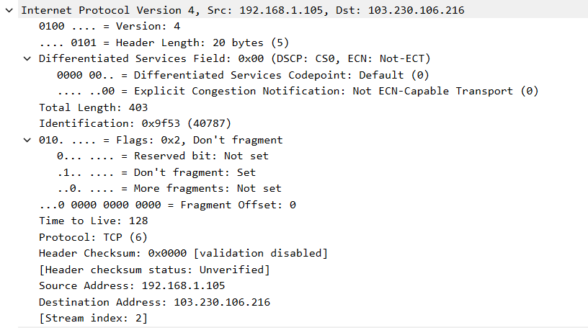
This header is responsible for routing the request from client to the server. It assigns IP addresses to the devices which allows them to communicate over networks.
Source(local device) IP address: 192.168.1.105
Destination(web server) IP address: 103.230.106.216
This layer is trying to access the website from the local device.
- TCP:
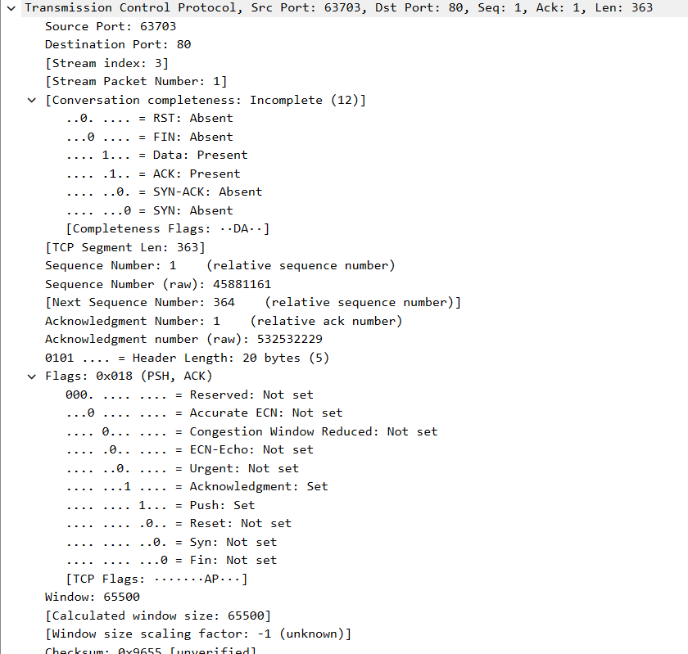
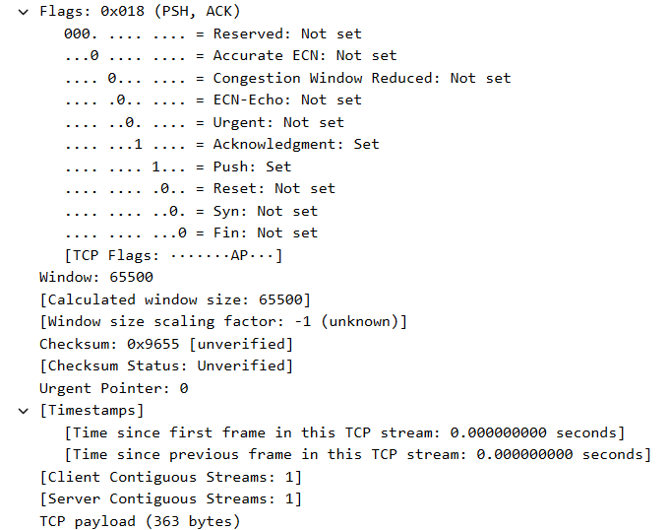
TCP ensures the data/request is transmitted reliably in order and without errors. This layer provides port addresses to the client and server, establishes a connection using a 3-way handshake , breaks the HTTP request into segments and reassembles them at the server and controls the flow and error of the data.
#Source port : 63703 ( taken as random)
#Destination port: 80, (http server’s port)
#Sequence Number: 1 , indicates the starting number of bytes in this segment of data
#Acknowledgment Number: 1 , confirms receipt of the previous segment of data.
The flags PSH and ACK are set, meaning the sender is pushing data to the receiver and acknowledging prior data. The TCP header length is 20 bytes with a window size of 65500, allowing flow control. No errors are shown in the checksum (0x9655) though it’s unverified here.

- HTTP
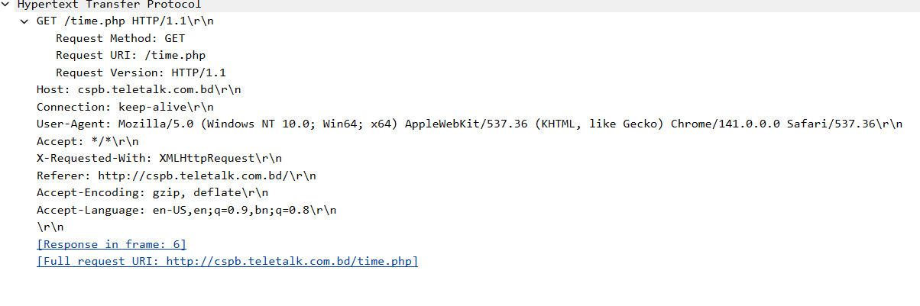
This layer is responsible for requesting and delivering the web content. The HTTP request is constructed by the web browser through the “GET” method and sent over TCP.The server processes the request and sends back an HTTP response. The HTTP layer shows a GET request for the resource /time.php using HTTP/1.1. The Host field is cspb.teletalk.com.bd, meaning the client is requesting data from that web server. The User-Agent indicates the request came from a browser.
The full request URI is http://cspb.teletalk.com.bd/time.php. This HTTP request is encapsulated inside the TCP segment for reliable web communication between the client and the server.

HTTP Response Packet
- Frame
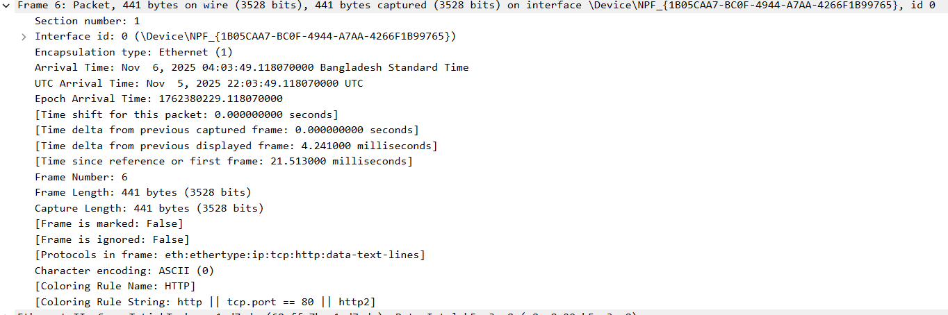
This ensures that the response is delivered to the correct device within the network. It falls under the data link layer.
- Ethernet
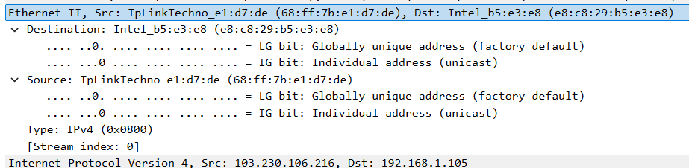
Upon clients request, the router is providing the MAC address of the requested website. Here source: 68.ff.7b.e1.d7.de and destination: e8.c8.29.b5.e3.e8.
- IPV4
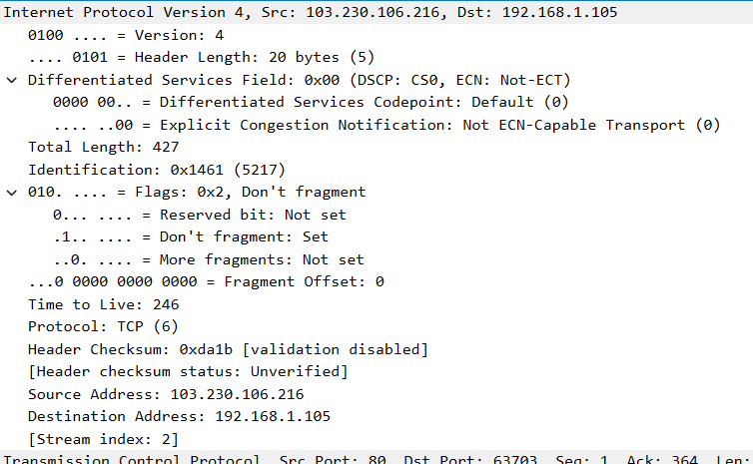
The ip addresses are interchanged in this phase which determines the receiving of the data from the server by the client. Source IP: 103.230.106.216 and Destination IP: 192.168.1.105
- TCP
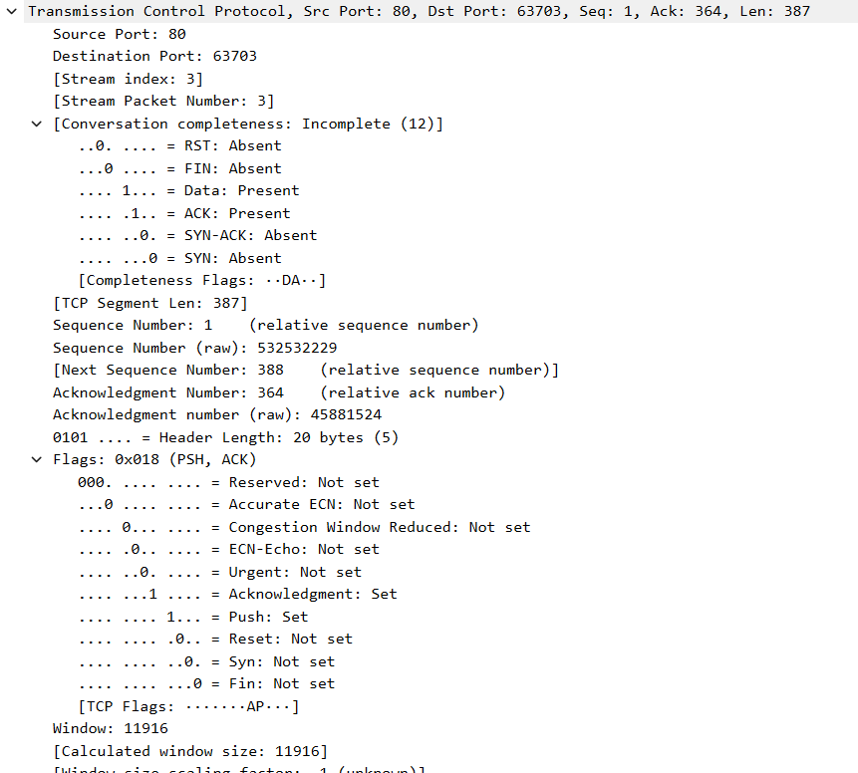
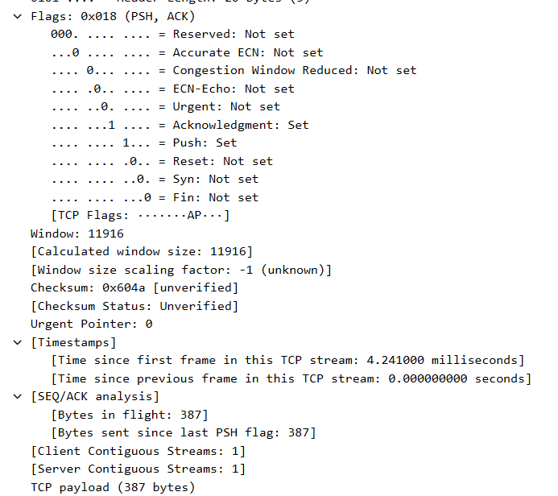
This layer the HTTP response is delivered reliably and in order. Here,
Source Port: 80 originated from web server
Destination Port: 63703 client server
Sequence & Acknowledgement Numbers: 1 & 364 , which Ensure data is received correctly. The window size of 11916 controls how much more data the server can receive before acknowledgment. The checksum (0x604a) is used for error checking but is marked unverified here.
In this layer,TCP acknowledges the request and sends the response reliably as well as all the tasks mentioned above in the Request’s TCP section.

- HTTP
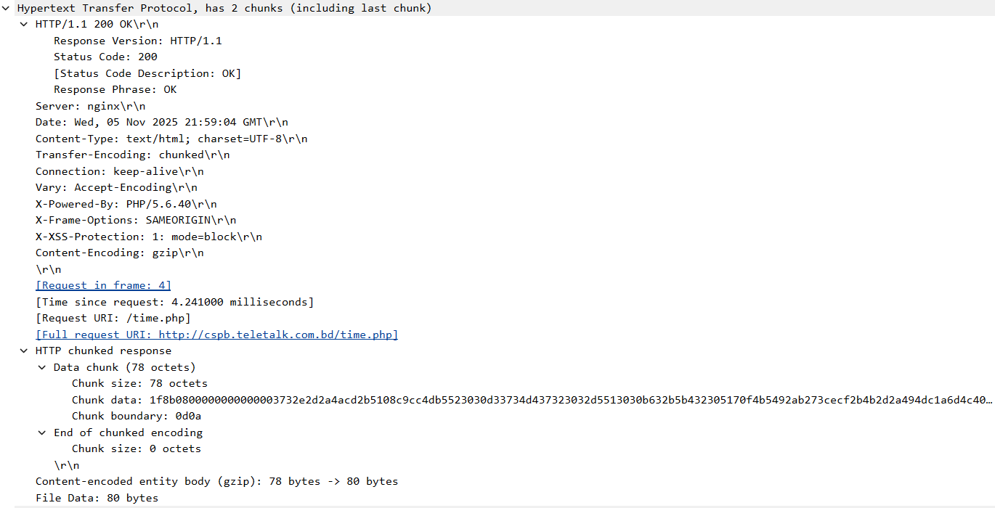
This is an HTTP/1.1 200 OK response, meaning the server successfully processed the request. The server is running nginx and responds with a text/html web page. It also shows that the data is sent in chunked format and compressed using gzip. At the bottom, you can see the actual chunked data that the server is sending back to the browser.
In this layer the server confirms the request was successful and returns the web content to the client.

